# Term Project Report

Intro/Proposal Summary and Description of Project/ Project Plan

* For the term project, we set out to create an online platform for users to share information with one another on local businesses’ sustainability practices. Users will rate businesses as they see fit in categories such as Waste Management and Ethical Sourcing, which would then be averaged across all users.
* In addition, by browsing through other user and business profiles, reading outsourced articles, and posting their thoughts on the home page, users will take part in lots of healthy discourse regarding the local environment.

Who Ecotopia Serves

* Ecotopia exists to serve a wide array of people, ranging from everyday consumers to local companies and small business owners looking to make their businesses more sustainable.
* A large portion of our main user base would be made up of socially conscious consumers, community advocates, and environmentalists, all people who value social responsibility and want to support businesses that engage in climate-conscious actions. These users are passionate about keeping their communities safe and green and would love to have a platform that could connect them with like-minded individuals in their area. Ecotopia would help them prioritize environmental sustainability, engage in discussions, share opinions, and act on eco-friendly practices.
* The other portion of our main user base would be made up of small business owners who are looking to connect with potential customers, promote their products or services, and engage with their community. These entrepreneurs can see Ecotopia as an opportunity to strengthen their presence, support their growth, and increase eco-friendly practices.

User Interface/Information Architecture, decisions made

* Our IA is a hierarchical structure, with the homepage.html as the main page and the business profiles, login pages, user profiles and map having their own branches.

* When the user first finds our website, they will find themselves at the login page where they can enter their username and password. If they do not have an account, they can create one on the Sign-Up Page.

* + If they forget their password, they can retrieve it here.

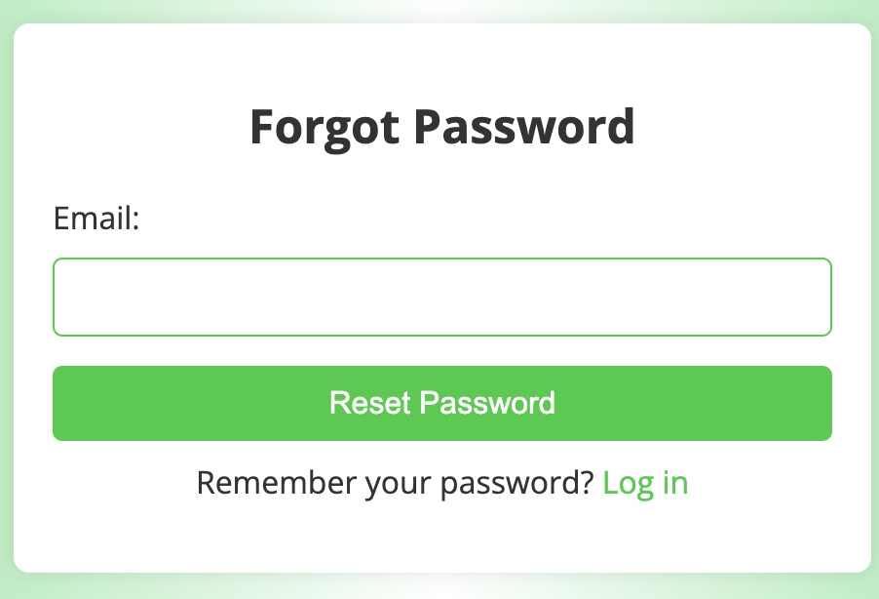

* + After logging in the user is redirected to the homepage, where they can search for articles, post their thoughts, and navigate to other pages.

* + The posts feature allows users to add their thoughts to a forum, cultivating a welcoming and nurturing environment for everyone to talk and learn from one another.

* + The articles feature allows users to learn from external articles, with the ability to search for what they want. There are also helpful tags shown beneath the article describing the content.

* + The navigation bar allows users to venture into all the other features of Ecotopia, including the business and user-profiles and the map. This navigation bar is present on many pages, allowing users to jump from one page to another without necessarily returning to the homepage.

* + The businesses page will allow the user to search for businesses, where they can click on one to see its specific page.

* + Within a given business page users can rate a given business, as well as find information such as similar businesses, their address, a description and of course their green rating.

* + Within the people section, users can do a similar search but instead for users. They can then browse their pages as well.

* + Finally, we have the map feature, which users can use to find the location of a given businessA map of a neighborhood

    Description automatically generated

Challenges

* During the development of the project, we faced many challenges. These challenges include data persistence in terms of managing user data in JSON files and properly parsing them, so user information is stored and displayed properly throughout each page. To fix these issues we had to create JSON files with all the information a user would need to log-in and then create a separate JavaScript file to read and parse the JSON file.
* Another data issue was ensuring that it was valid for each user, accurately displaying their name, username, and email on the home page. The main issue with making sure log in information matched the log in user across many pages was ensuring that the proper variable names were used in the HTML files for that site. In the JavaScript file that read the JSON file, there were many mismatched variables, so we had to go through and change the incorrect variable names.
* Another challenge was the DOM manipulation. Manipulating the DOM to dynamically update content, such as displaying user information or adding new posts was hard to initially code with HTML and we faced challenges during the debugging process to ensure it was fully functional. To have dynamically updated content, we referred to old labs where we dynamically added changes to our websites with Ajax, and it took lots of testing and debugging until this was achieved. Chrome Developer Tools proved to be a particularly important and useful tool throughout our debugging process.

Mockup

Log in page

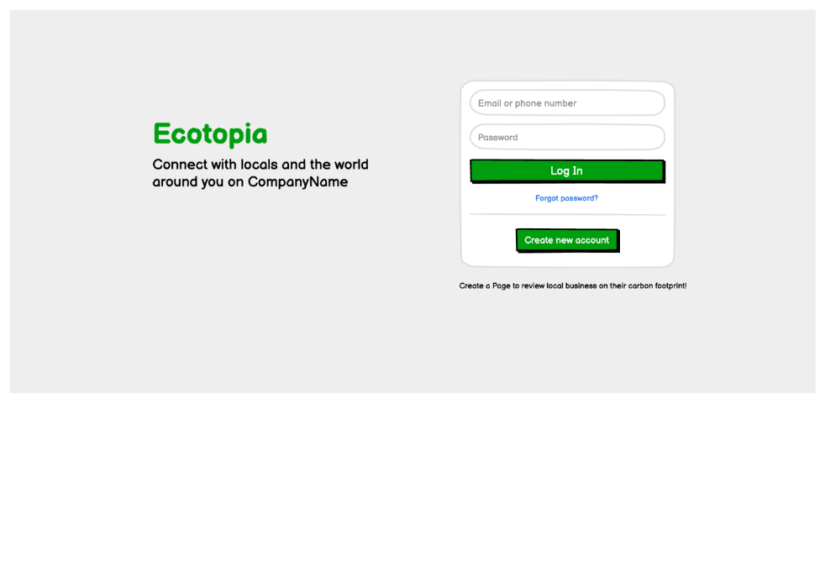

Home page, where you can create a post, view the news feed and what others have posted.

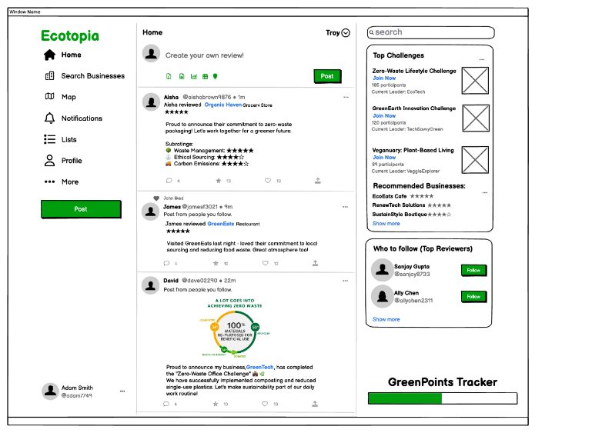

Page where the user would view another user's profile

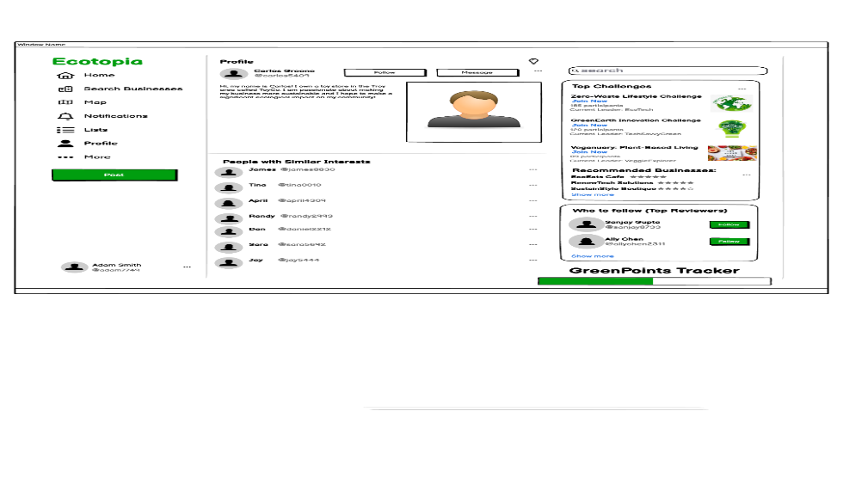

Page where the user would add a rating to a business in his town. The ratings are based on certain climate conscious criteria like waste management.

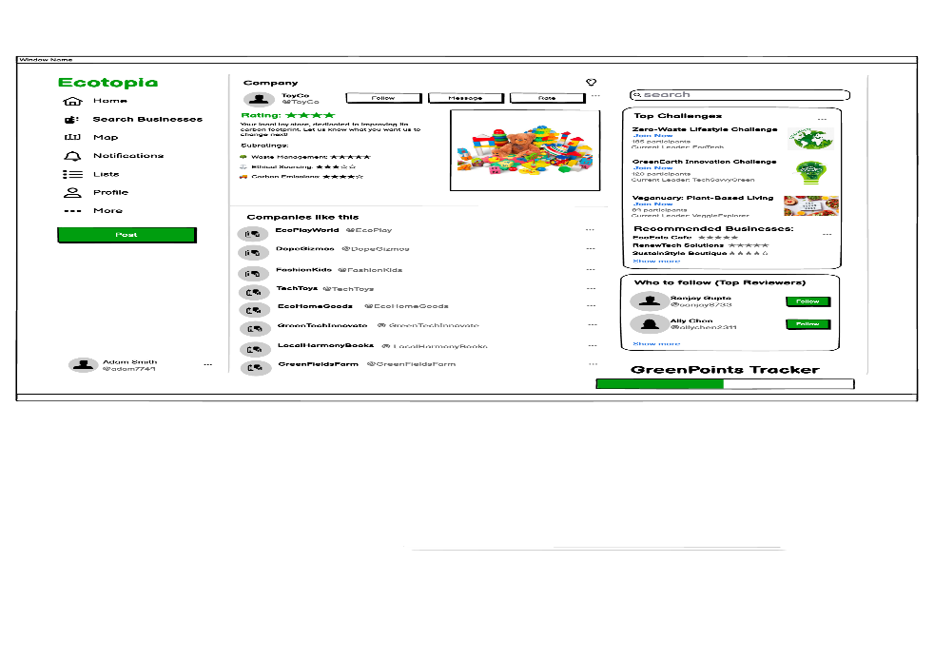

Map page – This Would show well-rated “Green” Businesses in the user's local area and the user’s current location. You could search for any business like a restaurant or store.

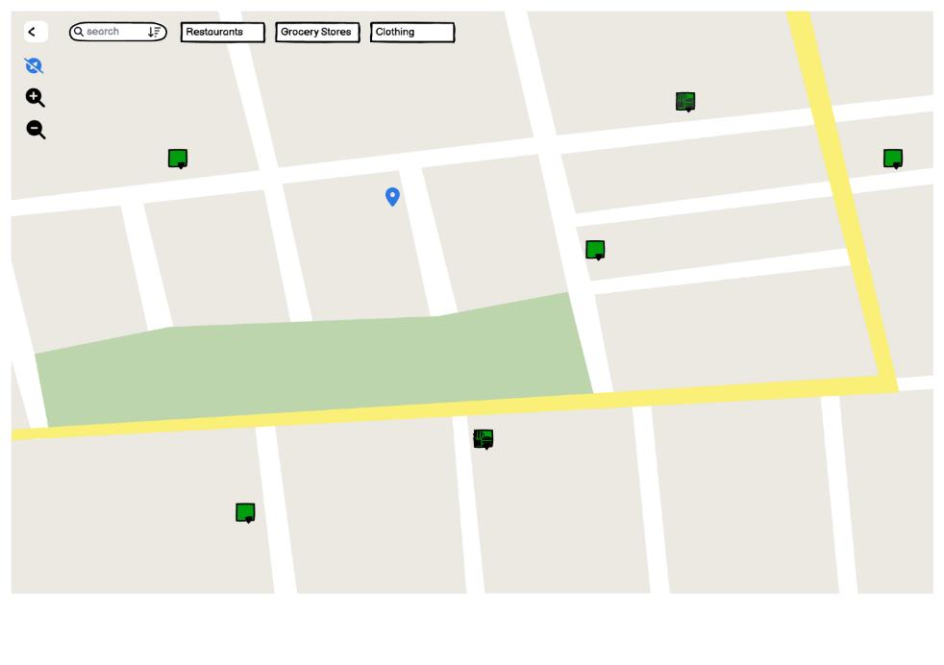

Use Cases/User Mockups

1. **Aisha Brown**
   * 28-year-old Finance Specialist at a Corporate Company
   * Lives in the Troy/Greater Albany area
   * She is a young woman living near Troy who has a passion for the environment and living in a healthy way. While she does not have a job or major hobbies revolving around sustainability, it is something she feels strongly and wants to stay informed about.
   * Some of her goals are to be active and informed for free, to be active and informed without spending much time, to be valued despite not having much expertise, influence etc., and to be around people who care similarly and can bring change.
   * Aisha has been frequenting a local clothing store named Ekologic for the past year. She loves their clothing, and especially appreciates their commitment toward sustainability by only using recycled and sustainable materials in their clothing. She would love to give them a positive review specifically about their green initiatives. She decides to visit Ecotopia’s website, where she first receives a login page with the options to login with her username and password, to create an account, or click the “Forgot password?” link. Since she has used Ecotopia before, and already has an account, she enters her username and password and clicks the Login button, which redirects her to Ecotopia’s homepage, which has a navigation bar on the left, a social media style feed in the middle, and a relevant articles section on the right. Since she has the goal of rating Ekologic, she goes over to the navigation bar on the left, where she clicks on the “Search Businesses” link. This redirects her to the business search page, which has a search bar to lookup businesses by name or category. She searches for “Ekologic” and clicks on the link titled “Ekologic” that pops up. This redirects her to Ekologic’s page, which consists of a picture, general information including a description and category, similar businesses, a Green Rating section, Waste Management Rating section, an Ethical Sourcing rating section, and a form field to rate the business and add a text review. The three rating sections are made up of an aggregate of ratings from previous raters of the business, and each contain a float number between 1 and 5. Since Aisha wants to rate the business, she navigates to the “Leave a Review” form field section, where she enters a 4.5 in the Green Rating section, a 4.3 in the Waste Management Rating section, and a 4.8 in the Ethical Sourcing rating section. She then adds a quick description of her ratings in the text review box detailing how she appreciates their commitment toward using recycled materials. She then clicks the submit button, and these ratings are added to the aggregate of ratings that make up Ekologic’s average ratings.
   * Since it is lunchtime and Aisha is hungry, she then navigates back to the “Search Businesses” page and enters “Mediterranean” into the search bar and clicks enter. Here, a link for the restaurant “Ali Baba” shows up, so she clicks on it and is brought to Ali Baba’s page. The page here has a similar format to Ekologic’s. Aisha sees that Ali Baba has a 4.5 Green rating, 4.0 Waste Management rating, and a 4.2 Ethical Sourcing rating, which shows that they are a pretty sustainable business. These good ratings prompt her to decide to visit Ali Baba, so she navigates back to the homepage, and clicks on the “Map” link in the navigation bar. This brings her to an interactive map that shows her general area and a search bar in the top right corner. After clicking on the search bar and typing in “Ali Baba Troy”, she is brought to Ali Baba’s location, with the business having a blue marker on it. From here, she can interact with the map and move it around to see exactly where Ali Baba is. Now, she can go back to the homepage and click the logout button on the bottom left corner, which brings her back to the sign in page.
2. **Carlos Greene**
   * Carlos is a 55-year-old man who lives around Troy
   * Carlos owns and operates a local toy store. While he is not very passionate about the environment, he recognizes that making his business more sustainable and advertising that could attract potential customers.
   * One of his main goals is to make a significant and/or long-lasting impact on his community
   * Carlos wants to interact with his community and learn more about what he can do to make his business more sustainable today, so he goes to Ecotopia’s page, clicks on the “New to Ecotopia? Sign up Here” link, fills out his details, and clicks the “Sign Up” button. Here, he is brought to Ecotopia’s main page, where he reads some of the posts that are at the top of his community feed. One of the posts about a local recycling initiative from a user by the name of Aisha interests him, so he decides to look up her profile. He clicks on the “People” link in the navigation bar, which brings him to a page similar to the “Search Businesses” page, except that it was to look up users using their name or username. Here, he searches for Aisha’s username and clicks on her profile link that shows up. This brings him to her profile, which has a picture of her, her email, and a list of reviews she has made on businesses. He takes note of a few businesses she has rated positively and goes back to the homepage, where he decides to make a post in the community feed describing a recent green initiative his toy store has undertaken. He writes the post, submits it, and sees it successfully added to the feed. He then decides to read about news relating to global warming, so he goes over to the news article section on the right side of the home page, types in global warming, and searches “Global Warming”. Two latest news articles relating to the topic show up, so he clicks on one of them, reads it, and learns something new. From here, he decides that he got what he needed from the website and decides to log out.

Project Summary

* We ended up with a fairly complete model/prototype of a new type of social media platform. We had functioning log-in and sign-up features, abilities to view other profiles, create posts, rate local businesses on many different criteria, and the ability to view a map of your area and find businesses in your area. We learned how to adequately work in a group and distribute work, and how to help each other complete the site's goals. All of us reinforced our programming abilities with what we have already done in class and even learned more about APIs and code libraries to implement on our website. Next, we would like to use a database to store new and past user information like passwords and usernames to add for smoother login without the need for JSON files. We would also modify how to find users since there would be a new way of storing their information. Another feature we would like to improve is the forgotten password feature, where we would have an email sent to the user who forgot their password so they could change it and save the new password into our database. We would like to create the database using PHP and MariaDB.